**Project Design Phase**

**Problem – Solution Fit Template**

|  |  |
| --- | --- |
| Date | 25 June 2025 |
| Team ID | LTVIP2025TMID59612 |
| Project Name | SB Foods - On-Demand Food Ordering Platform |
| Maximum Marks | 2 Marks |

**Problem – Solution Fit Template:**

The Problem-Solution Fit simply means that you have found a problem with your customer and that the solution you have realized for it actually solves the customer’s problem. It helps entrepreneurs, marketers and corporate innovators identify behavioral patterns and recognize what would work and why

**Purpose:**

* Solve real-world food ordering challenges faced by customers, restaurants, and administrators.
* Accelerate solution adoption by integrating into users’ existing habits and behaviors (e.g., mobile usage, contactless delivery).
* Improve communication through clear, focused messaging that resonates with user needs.
* Build trust by solving recurring issues and streamlining the ordering experience.
* Analyze and improve the current food ordering ecosystem by identifying gaps.

**Template:**

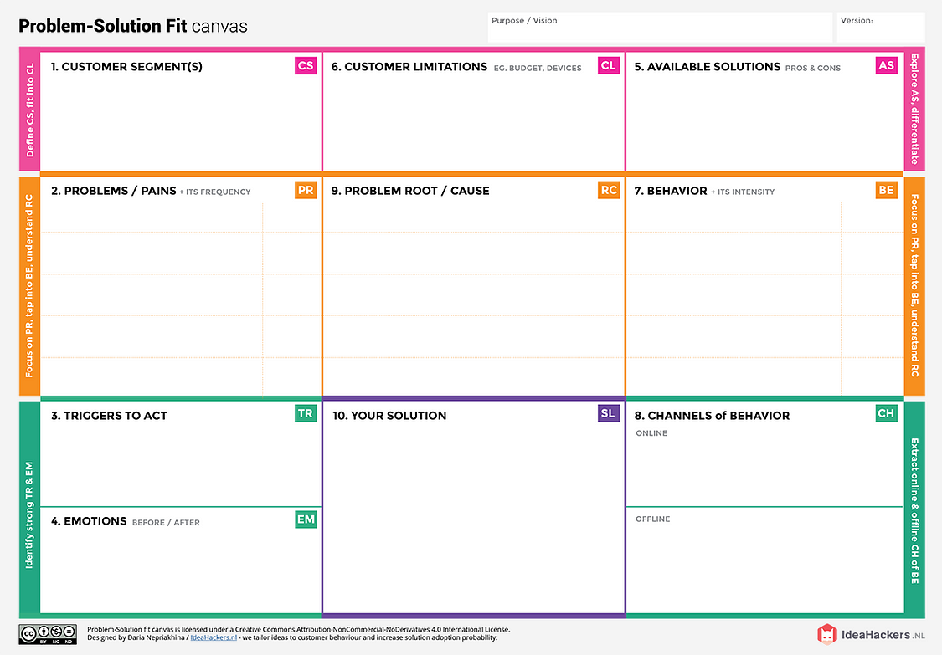

SB Foods app with dedicated “Late Night Cravings” section  
Only displays open restaurants for current time and location  
Instant ordering, saved profiles, & secure payments  
Feedback-driven AI suggestions and simplified UX for night use

Lack of 24/7 food access  
Mainstream food apps not optimized for late-night users  
Limited awareness of available open vendors  
No specialized interface for midnight cravings

Word-of-mouth in hostels, campus boards  
Rarely visits stores late night due to safety concerns

Mobile apps (primary), social media, food forums

High urgency during late-night hunger  
Frequent use of food apps  
Impulsive behavior in food selectionRelies on reviews or past orders

Limited student budget  
Dependent on mobile phones (Android/iOS)  
Prefers apps with wallet/UPI options  
Internet availability in hostels may be poor sometimes

**Zomato/Swiggy**: Popular, but coverage varies & late-night options are limited  
**Instant noodles/snacks**: Quick but unhealthy  
**Canteens/local eateries**: Usually closed late night  
**Calling restaurants directly**: No real-time menu, no guarantee

**Before**: Hungry, tired, frustrated, anxious  
**After**: Satisfied, relieved, focused, cared-for

Physical hunger or skipped meals  
Peer recommendations  
Pop-up notifications offering late-night discounts  
Exam stress or long work hours

Hunger during late hours  
Limited/no food options after 11 PM  
Unreliable delivery services  
Time wasted browsing for open vendors  
Security concerns going out at night

College students (18–25 yrs), night owls  
Working professionals with irregular hours  
Hostel/PG residents  
Single urban dwellers relying on food delivery

**Summary:**

SB Foods solves a **common**, **frequent**, and **costly** problem in a simple and clear manner:

* **For users:** No more app clutter or guessing what’s available.
* **For restaurants:** Independence and visibility.
* **For admins:** Simplified moderation and system health.

The solution is crafted to match existing user behavior (mobile-first, fast decisions), and taps into pain points faced in conventional apps. This ensures **higher adoption**, **repeat usage**, and **stakeholder satisfaction**.

References:

1. <https://www.ideahackers.network/problem-solution-fit-canvas/>
2. <https://medium.com/@epicantus/problem-solution-fit-canvas-aa3dd59cb4fe>